**Datavision/Unio First Time Login**

**Purpose: To provide a step-by-step guide for a new user when signing into the Datavision and Unio platform.**

1. Access the **Datavision** platform by going to [**https://dvlogin.com**](https://dvlogin.com)and selecting the appropriate broker dealer CFS or SPF.

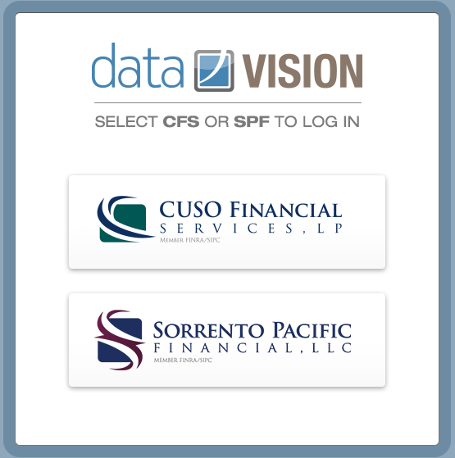

1. Enter your **userID** and select **Continue**.

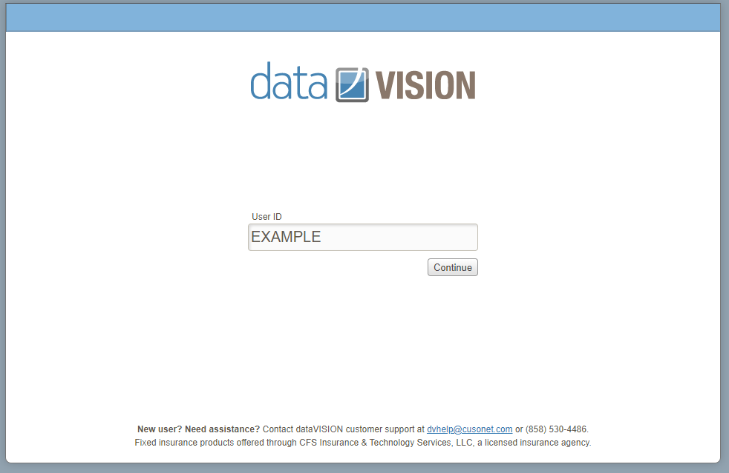

1. Complete the initial security setup. This will include setting up a security photo, security phrase along with 4 security questions.

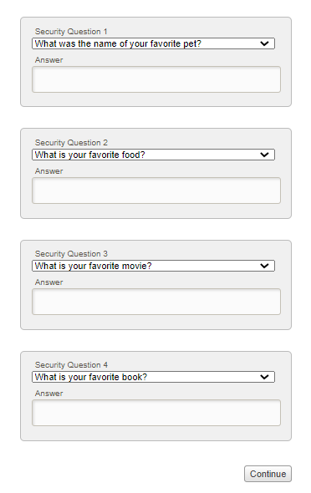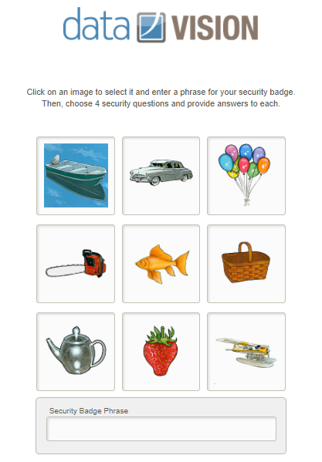

Once complete, it will route you back to the main login page to input the initial password.

The passwords are always going to be set to **first initial, last initial, birth month** and **birth year** (Example – te011999)

1. When you continue, a new screen will appear to allow you to update the password. Once you have confirmed the information, click on **Save.**

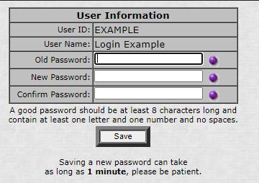

1. Once the password is updated, it routes you back to the main login page to re-enter the new credentials.
2. Once signed in, the system will automatically route you to the Unio platform. The system will sign you in at the same time, which creates one sign in session, that allows the user to access both platforms.

To toggle through each platform, there are banners that act as a single sign on back to the previous system.

**Datavision**

The banner will appear on the main home page.

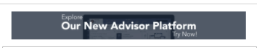

**Unio**The banner will appear in the upper right-hand corner next to the search box.

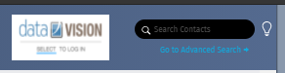

**Unio Practice View Setup**

Your dashboard is composed of a series of tiles. Customize how you view your practice through Manage Tiles. Select the tiles most important for your business and update the layout to suit your needs.

Select MANAGE TILES from the top right corner to manage which tiles are displayed or to change the location of any tile.

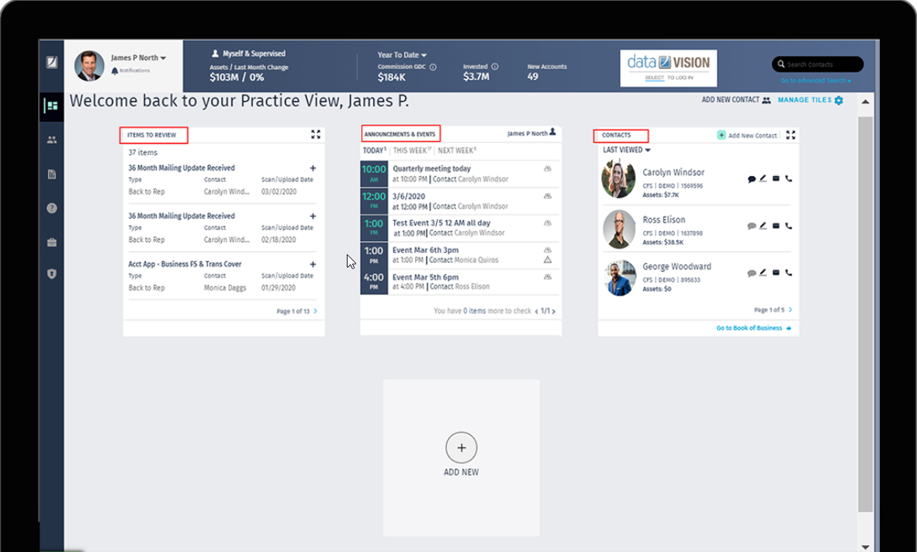

If you have any questions, please contact the Help Desk at [dvhelp@cusonet.com](mailto:dvhelp@cusonet.com) or (888) 566-1482, Option 2.